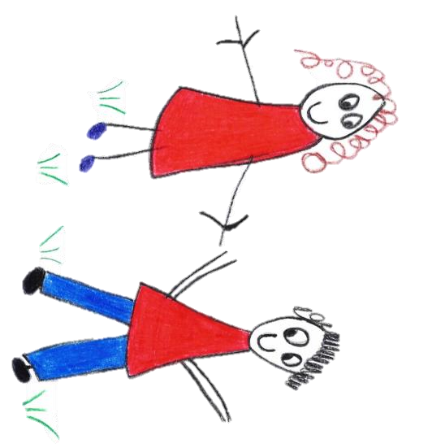

Hyde Heath Pre-School
Have fun and learn!
Prospectus
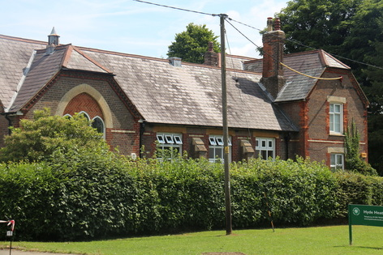

Registered Charity Number 1020591
Hyde Heath Infant School, Weedon Hill, Hyde Heath, Amersham, Bucks, HP6 5RW
Tel: 01494 782845

Contents

Page No

Introduction  About Our Pre-School | 3
Our Children  Admissions | 4
Where we are  Our location and our community | 5
Opening Hours | 6
The Team | 7
Facilities | 8
Learning | 9 – 10
Uniform | 11
Pre-School Committee | 12
Fees  Contact Us | 13

About Us

- At Hyde Heath Pre-School we offer a happy, secure and nurturing environment for your child, where learning is always fun.

- Hyde Heath Pre-school is a registered charity run by Trustees in partnership with parents, Early Years Practitioners and other members of the community. We welcome new volunteers to join our committee.
- We promote a positive approach to learning where our children are encouraged and stimulated through a wide range of resources and creative activities.

- Our caring, dedicated and well qualified team of Practitioners aim to build strong relationships with children and parents to support and adapt to children’s individual needs.

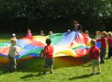
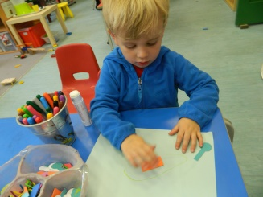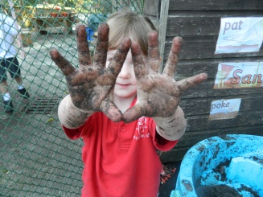

We offer your child:

- A specially tailored curriculum leading to approved learning outcomes from the Early Years Foundation Stage. All children in the setting are guided in a way appropriate to their age and stage of development.
- Individual care and attention made possible by a high ratio of Practitioners to children.
- Fun and friendship in an exciting, caring and safe environment.
- The support of a personal Key Worker.
- Equal Opportunities for all families and clear policies to ensure the safety of our children is protected at all times.
- Opportunities for you and your family to be directly involved in the Pre-School community, activities of the Pre-school and in your own child’s progress.

Our Aims

- To enhance the development and education of children under statutory school age in a parent-involving community-based setting.
- To provide a safe, secure and stimulating environment.
- To work within a framework, that ensures equal opportunities for all children and families.
- We support Early Years development and aim to provide your child with the skills, independence, self- confidence and desire to learn, in order for children to move onto School with a strong foundation in place to support further learning.

Our Children

Admissions

- We welcome children between the ages of 2 years 6 month to rising 5 years old.
- We can accommodate up to 22 children in each session.

Special Educational Needs

- We understand all children are unique and should have the opportunity to celebrate and value their own and others’ endeavour. Therefore all our children will be given equal access to resources challenging, extending and supporting their understanding. Your child is able to progress at his/her own rate in all areas of development.
- We ensure that you as parents are informed at all stages of the assessment, planning, provision and review and will liaise with other professionals involved with your child. If you have any concerns regarding your child's development, please speak to your key person.
- Our full Special Educational Needs & Disabilities Policy is available upon request.
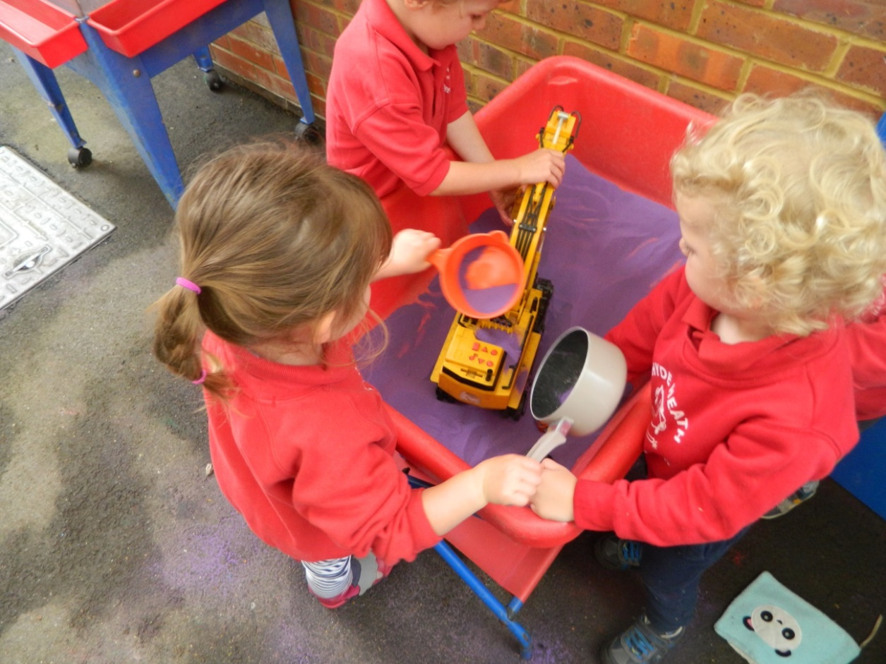

Our Location and our Community

- We provide a safe, high-quality learning environment in a classroom within Hyde Heath Infant School, Weedon Hill, Hyde Heath, Bucks, HP6 5RW
- We maintain close links with the highly successful infant school.
- We are located in the small, picturesque village of Hyde Heath, two miles from Amersham, which has a strong community feel. Pre-School enjoys supporting local annual events.

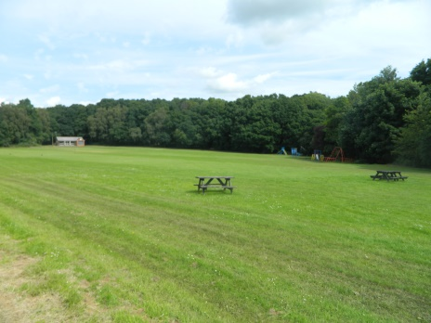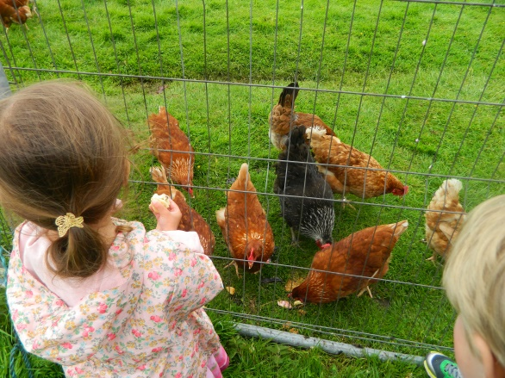

Getting to School

- We encourage you to walk to school with your child, who may also wish to make the journey by scooter or bike which you can leave at the Pre-school. However, Pre-School does not accept responsibility for loss or damage.
- Parking is very limited close to Pre-school:-
Please park away from the school site in the village and walk a short distance to Pre-school. If you must park on site please only park along the log lined side of the unmade road opposite the school. Large vehicles regularly need access to the businesses further down the track. Emergency vehicles also must have access. DOUBLE PARKING ON THE UNMADE ROAD IS NOT ALLOWED AS IT PREVENTS ACCESS TO THESE VEHICLES AND COULD RESULT IN DAMAGE TO YOUR CAR.

- Please do not park in residents’ driveways or on the track behind the houses on the common;
- Always drive with great care in the vicinity of Pre-school and throughout the village when children may be about. A 30mph speed limit applies throughout the village and we urge you to respect it at all times for the safety of our children.

Opening Hours

- The Pre-school teaching calendar normally matches the local term times of the Local Education Authority, Buckinghamshire County Council. For details, see http://www.buckscc.gov.uk/sites/bcc/schools/term_dates.page
- Pre-school is open 9am–3pm, Monday to Friday, 38 weeks per year. Pre-school may occasionally be closed during these times for public holidays or training days.
- Children are taught in a choice of two sessions a day, five days a week: 9am–12pm and 12pm–3pm.
- Pre-School is structured to offer a high level of flexibility to parents. Privately and state-funded places can therefore be taken in any combination, subject to availability. Ad Hoc bookings can be made in advance with our Pre-school Manager or Admin Assistant.
- After completion of a Registration Form, Pre-school will confirm your booking and the scheduled start date in writing, as well as offering you and your child a settling in session to enable familiarity with the building, Practitioners and children. In the event that a place is not available, we will contact you as soon as we can offer your child a place.
- Pre-School may not open on certain other days to allow for staff training (Inset Days), but due notice of such closures will be given to all parents and relevant refunds will be made.
- Please read our Terms & Conditions carefully for full details of your responsibilities for the collection of your child.

The Team

- We benefit from a well-qualified, experienced and committed team, some of whom have worked at the pre-school for over 10 years.

- Our current Manager has a BA (Hons) Degree in Education Studies and a Foundation Degree in Early Years Education & Child Development and our Deputy Pre School Leader is a Qualified Primary Teacher. All other Practitioners are qualified to Level 2 or Level 3 in Pre-school Practice/Early Years.
- All staff are Paediatric First Aid qualified.
- Further information on all the Practitioner’s qualifications and experience may be found in the Staff Training Folder which is available on request at any time.

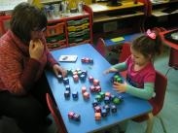
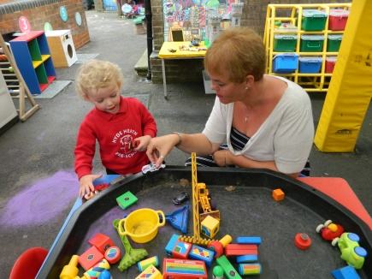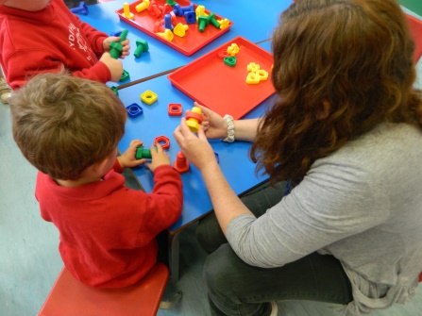

Key workers

- Our Key Worker system means that a particular Practitioner has responsibility for your child. From the outset, observations and photographs of your child at Pre-School are recorded in each child’s Learning Journey and will be used to assess your child according to Development Matters in the Early Years Foundation Stage. These assessments are in turn used to inform future planning. The key worker maintains links and works with you using these records. Parents are invited to bring pictures from home and any observations you make of your child which can be included in your child’s Learning Journey.
- The team tailors the Pre-School curriculum to the unique needs of your child, thus ensuring all children are supported in reaching their full potential.

Training/Qualifications

- Our membership to the Pre-School Learning Alliance ensures that we are constantly in touch with new thinking and best practice in the field of Early Years Education and care. We have access to a range of professionally produced publications and professional support. On-going training and support is available for our Practitioners and parents through courses run by providers such as Buckinghamshire County Council.

Facilities

The indoor classroom offers well-defined areas of learning. This includes a designated quiet reading area with listening table, ICT facilities, play dough table, construction area Literacy & Numeracy areas, craft/art table and a small world play area.

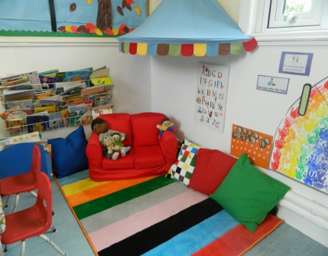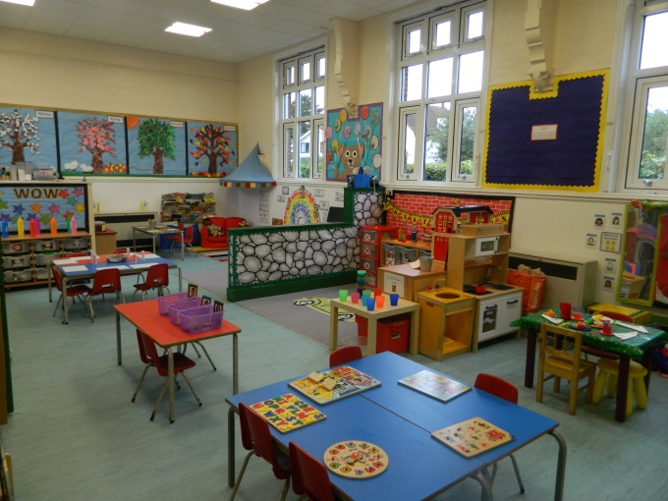

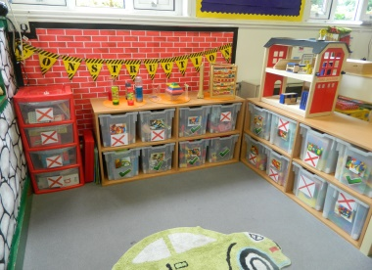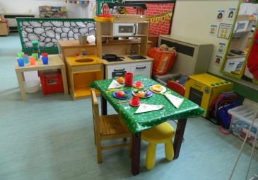

The outdoor classroom is also set out into well-defined areas of learning and includes a canopy, much loved chalet house for role play, a mud kitchen, sand tray, digging area, water play, music stand, big wheeled toys, balance bikes and scooters, Physical Development equipment, craft/art table, writing table and large construction.

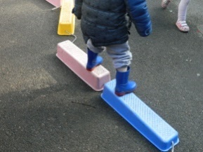
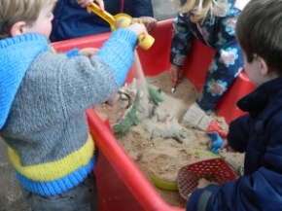
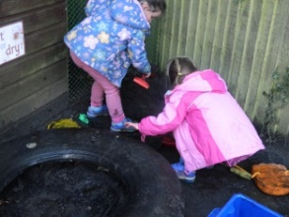
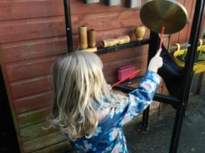

In addition to the Pre-School classrooms children also benefit from access to the play areas and other appropriate resources within the Infant School.

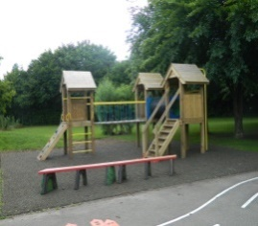
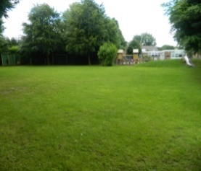
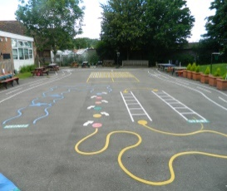
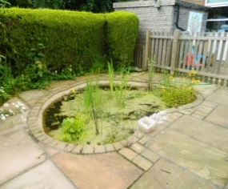

Learning

- Our standards are inspected and regulated by the government’s Office for Standards in Education, Children’s Services and Skills (Ofsted). Following our last inspection, in February 2015, the quality of the provision was deemed good. See: http://www.ofsted.gov.uk/oxcare_reports/display/(id)/235768
- Our Trustees and skilled Practitioners work closely with Early Years Learning Advisors in Buckinghamshire County Council to maintain and develop our high standards.
- The learning needs of children change as they grow from 2 and a half years to rising 5’s. Every child is unique, therefore a curriculum is planned which takes into account each individual child, their age and stage of development and their learning requirements. Your child’s Key Worker is closely involved with this process.
- Children’s learning follows guidance set out in the Statutory Framework for the Early Years Foundation Stage, Development Matters (Department for Education, September 2014)
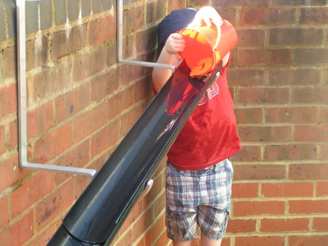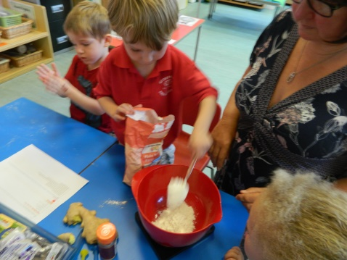

Early Years Foundation Stage (EYFS)
- Within the Pre-school your child will be supported to develop their potential at their own pace in the 7 areas of Learning. Our key worker system enables us to provide a planned curriculum tailored to the needs of your child.
- Our curriculum is based around the Early Years Foundation Stage Development Matters. This is where your child’s learning journey through play activities begins, complimented with meaningful focused activities & play facilitated by Practitioners, as well as child initiated play. It will develop your child’s:

Personal, Social and Emotional Development: in particular by supporting the transition to and between settings, promoting an inclusive ethos and providing opportunities for your child to become a valued member of the setting and community, enabling children to build a strong self-image and have high self-esteem. To develop positive attitudes and an enthusiasm for knowledge and learning, enabling your child to learn how to cooperate and work harmoniously alongside others, as well as listening to others.

Communication and Language: with opportunities for your child to talk and communicate in a widening range of situations, to respond to adults and to other children, to practice and extend the range of vocabulary and communication skills they use and to listen attentively. Children will develop their understanding of words, concepts and the use of objects, as well as learning how to use sentences to express their thoughts, feelings and ideas in their play.
Physical Development: with opportunities for your child to develop and practice their gross & fine motor skills and to increase their understanding of how their bodies work and what they need to do to be healthy and safe.
Literacy – Reading and Writing: with opportunities for your child to explore, enjoy, learn about and use words and text in a broad range of contexts, such as rhymes, poems, songs, jingles, role play and stories, as well as experiencing a rich variety of books. Across the 7 areas of learning children will have a variety of mark making and writing opportunities to encourage meaning in the marks they make, this is known as emergent writing, moving on to forming recognisable letters.
Mathematics: with opportunities for your child to develop their understanding of grouping, quantity, comparing, mathematical language and numbers through number rhymes, number stories, counting and problem solving strategies. Children will also be given opportunities to categorise objects, explore time, weight and length using standard and non-standard units as well as ordering, build and construct using shapes and use mathematical language to describe shapes through the provision of exploration, experimentation, practise and talk.
Understanding the world: with opportunities for your child to solve problems, make decisions, experiment, predict, plan and question in a variety of contexts, and to explore and find out about their environment, people and places that have significance in their lives. As well as learning through technology, via the use of computers, cameras, video recorders, remote control toys, voice recorders and Beebots.
Expressive arts and design: with opportunities for your child to explore and share their thoughts, ideas and feelings through a variety of art, design, technology, music, movement, dance, imaginative and role play activities.

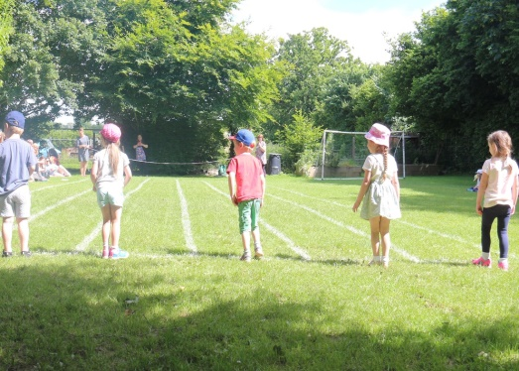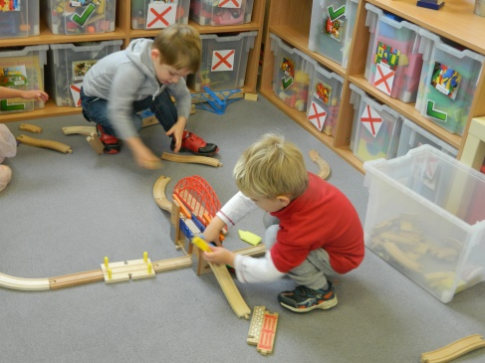

Your Child’s day at Hyde Heath Pre-School

9.00am Children Enter Pre-School and Settling Activities
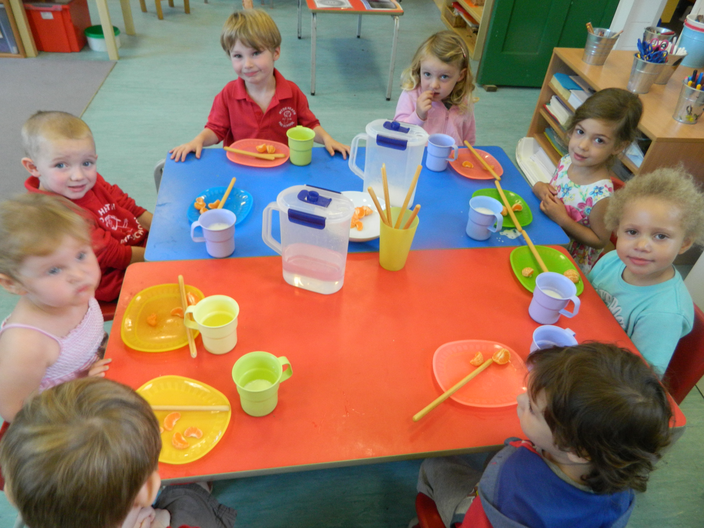
9.25am Key Person Groups
9.35am Child initiated and Adult Led Activities
10.30am Snack
12.00pm Home or Lunch and Afternoon Session begins
12.30pm Key Person Groups
12.40pm Child initiated and Adult Led Activities
2.30pm Snack
3.00pm Home or Lunch and Afternoon Session begins

Uniform

- Uniform is not compulsory, although we do find many children enjoy wearing their uniform to Pre-School. You can order sweatshirts and polo shirts sporting our Pre-School logo using our dedicated form available from Pre-School and online.
- If uniform is not worn, we recommend that your child wears clothes that are easily washable and not too new. This enables them to feel free to explore and experiment with all kinds of materials, including messy ones.
- Children like to practise the skills that make them independent. Simple clothing, which your child can handle themselves, will enable them to go the toilet when they want to and put on their outdoor clothes without being too dependent on others.
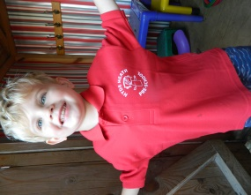

Clothes and shoes
- Please clearly mark your child’s footwear, coats and other belongings with your child’s name.
- If your child arrives in wellington boots on wet days, please provide a change of footwear; this will allow us to keep the classroom floor and furniture clean and dry.
- In the winter we ask that you provide your child with a warm, waterproof winter coat, hat, scarf, gloves and welly boots as children access outdoor learning every day, whatever the weather (with the exception of high winds and lightning).
- In the summertime we ask that you provide your child with a sun hat and apply sun cream before they arrive in setting.

Settling children into Pre-school

- A child who is tense and anxious or unhappy in the setting will not be able to learn to their full potential and may also find it difficult to make friends. It is important for you and Pre-School Practitioners to work together to help your child feel confident, secure and settled. More information is available in our Settling in Policy.

Pre-School Committee

- Pre-School is run by an elected Board of Trustees, who tend to be parents of Pre-School children and members of the local community. This ensures that parents are involved in the major decision-making of the management and development of the Pre-School.
- It is essential that some current parents are willing to be Trustees, as the charity cannot run without them. We hope you will consider joining us. We also welcome others who are able to make a regular commitment and a clear contribution to the charity’s work. Simply contact the Chair of the Trustees to discuss your involvement.
- Trustees are responsible for reviewing both policy and practice, and for the employment of Practitioners. Our Annual General Meeting, at which the Trustees for the following year are elected, is usually held in the summer term. You will be informed in good time so that you can attend.
- The Trustees have three post-holders: Chairperson, Treasurer and Secretary. There must be a minimum of three Trustees and in recent years there have been between seven and ten.
- Regular meetings are held throughout the year. These meetings allow the exchange of information and ensure the smooth running of the Pre-School.
- Being involved with the Pre-school is a highly rewarding experience that supports our role in providing high quality education and not only is it a great way to get to know the Practitioners better and to meet other parents, it’s also hugely fulfilling and great fun. Furthermore, it gives you the opportunity to have a real influence on your child’s Early Education.

Parent Support

- Research has shown that children’s learning is enhanced when their parents are actively involved. Parents and carers are encouraged to participate in the life of our Pre-School. If you have a job or skills you think our children may be interested by please do speak with our Manager so arrangements can be made for you to come into setting to share your job and skills with the children.

Fees

- We charge fees for children aged 2 and a half years (“privately-funded children”). In some circumstances, Local Authority Early Education Funding may be available for children aged under 3. Please ask us for details about the terms and conditions for your child's academic year.
- The state pays for up to 15 hours of pre-school learning in each term week for children aged 3 years to rising 5’s (“state-funded children”). This funding is available from the term following their third birthday. We claim the funding directly from Buckinghamshire County Council on your behalf.
- We also charge fees for children attending sessions above the 15 hours per week paid for by the state (“privately-funded children”).
- The cost of a Pre-school session is currently £16.00 for your child.
- If a privately-funded child attends part of a 3 hour session, you will still be charged for a whole session. If a state-funded child attends part of a 3 hour session, the entire 3 hours will be included in your child’s 15 hours entitlement.
- We accept Childcare Vouchers.

Contact Us

Do you have any questions?
If you have any questions or would like to arrange an appointment to visit the Pre-School, please contact the Pre-School Manager Claire Rutherford:
- Email: manager@hydeheathpreschool.org.uk
- Phone: 01494 782845
- Viewing is by appointment only due to Safeguarding Policy

